SFU
CMPT 275 Summer 2012 Assignment 2A

School of Computing Science
Simon Fraser University
8888 University Dr.
Burnaby, BC, V5A 1S6

SFU Path
Requirements and Initial Design
designed and written on
June 2012

Instructor | Dr. Herbert H Tsang | htsang@cs.sfu.ca
TA | Jian Jin (Amy) | jiaoj@sfu.ca

Project Group 6
Student | Terence Chan | jienanc@sfu.ca
Student | Jon Holmes | jeholmes@sfu.ca
Student | Abel Lin | kla73@sfu.ca
Student | Erik Ross | eross@sfu.ca
Student | Yang Zhang | yza157@sfu.ca

Revision History

Revision | Status | Publication/Revision Date | By
1.0 | Created  -Template Created  -Assign tasks | May 31st, 2012 | Erik
2.0 | Revised  -Fill in introduction  -Fill in intended audience | June 2nd, 2012 | Yang
2.1 | Revised  -Fill in functional Requirements | June 2nd, 2012 | Yang
2.2 | Revised  -Fill in non-functional requirements | June 2nd, 2012 | Terence
2.3 | Revised  -Fill in example tutorials | June 3rd, 2012 | Yang, Erik
2.4 | Revised  -Add mock up images | June 3rd, 2012 | Erik
2.5 | Revised  -Organize Document  -Add tables  -Create table of contents, glossary | June 4th, 2012 | Abel
3.0 | Final Revision  -Check document requirements and grammar | June 7th, 2012 | Erik

Table of Contents
- Introduction ………….………………………............................................ 01
- Intended Audience ……………………………………………….………………….. 01
- Features/Functional Requirements ………………………………………….. 02
- Non-functional requirements …………………………………................... 06
- Example Tutorials....…………………………………………………................. 07
- Glossary.…………………………………………........................................... 08
I. Introduction
“SFU Path” is generally an interactive map of SFU Burnaby campus for iOS devices. However, in terms of its unique functionalities, it is much more than just a map in your palm. This system is based on a detailed map of SFU Burnaby campus, on which all room numbers are displayed. All its services are realized on this map. User can simply browse the map to get a general idea of the geographical distribution of rooms and facilities in SFU Burnaby campus. “SFU Path” offers path finding service as its primary functionality. This function asks for the destination that user wants to go, and calculates the best route from user’s current location to his/her destination. In order to locate user, system first takes advantage of devices’ built-in GPS-based location service to automatically retrieve current location. In addition, scanning QR codes that are placed around the campus and manually input by user also help with the precision of user’s location on the map. Specific “Landmark” rooms such as CSIL labs and TASC buildings would be placed in an easy-to-access section of the drop down menu so that user can either choose from it or type in the search bar. Information about these more important locations will be provided as user finds them on the map. Other campus services such as food and beverage, public transportation and parking information would also be provided if requested by user..
II. Intended Audience
SFU Community, including students, faculty members, staffs, residents and visitors.
Students of SFU
“New to SFU” students
Navigation service is especially needed by students who are new to this campus. New students usually spend the first a couple of days after arriving getting familiar with the surroundings, locate their classrooms and memorize those locations. They can be freshmen that just graduated from high schools, graduate students from other colleges that seeking for further education after getting a bachelor degree or part time adult students who spend only one day on campus taking continuing study courses for their own interests.

Returning students
Although having spent some time on campus, many students still find it hard to find a specific location on campus. Normally students do not pay attention to places that they believe currently has nothing to do with them. Therefore, their knowledge about the layout of Burnaby campus is also limited. Many returning students will do exactly the same thing as new comers that wonder where the classrooms are and which directions they should go.

Faculties and staffs
Faculties are such a group of people that will benefit from the system. Although, for most of the time, faculties can decide which courses they are going to teach, they cannot decide where they teach. Like new students and returning students, new faculties may need navigation service more often, whereas other faculties can still found the system useful when they found their destinations look unfamiliar. Most staffs don’t need to move around all the time, but the system can make their lives much easier when they are facing a situation that being asked to attend a meeting in where they have never been before.

Visitors to SFU Burnaby Campus
Lots of events are held at SFU Burnaby campus. Therefore many visitors visit this campus throughout the year. Visitors can be scholars come to attend meetings and conferences, sports athletes come for games with SFU Clan teams, and even people who just come for camping. Since general visitors do not stay long on campus for each time, it’s hard for them to memorize details of locations. Most visitors come to SFU for specific purposes. Therefore, getting to the destination through a faster and convenient route is desired. Apart from routing function, visitors will be using “landmark” information more often since regular campus services such as food and parking should also be navigated.

III. Features/Functional Requirements
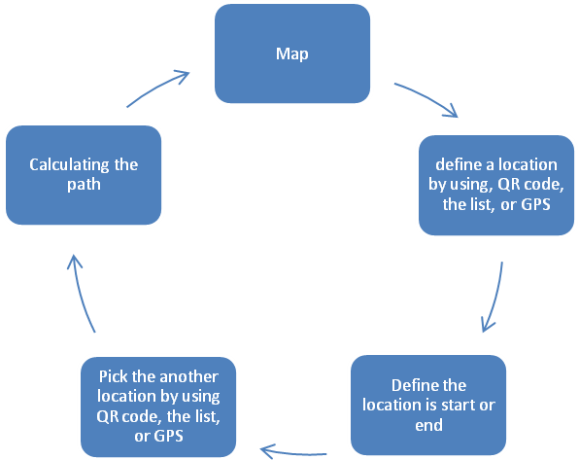
Figure 1. Flow Chart of the application.

Main Page - MAP
When the application is launched, it will display the map page, and a less-detailed general SFU Burnaby campus map with only coloured building shapes and names will display and initially centered at Academic Quadrangle.
User should be able to move and browse the general map by dragging on the screen. When user pinches on the map, map will be zoomed in or out. When the map is zoomed in for 300%, it should turn to the detailed map of the building which is currently at the center of the general map. After the map is turned into detailed building map, user should still be able to move and browse by dragging on the screen.

Functions Bar
There will be a search bar that is always on the top of the application. Also, there are Home, Locate, QR, List buttons on the bottom of the application.
Buttons | Functions
Home | Will go back to the map, and display result or path on the map.
Locate | Using GPS to find the closest point that is on the list of rooms, and start to find the path.
QR | Scan the QR code using camera to find the point that is matched in the list of rooms, and start to find the path.
List | Select the location from the list of rooms, and start to find the path.
Search bar | Quick search on the list of rooms, and start to find the path.

Table 1. Summary of the functions buttons.

Detail Requirements
- Launch SFU Path Application
  - When the application is launched, a less-detailed general SFU Burnaby campus map with only coloured building shapes and names will display and initially centered at Academic Quadrangle
  - Following element(s) will display at the top of the screen when the application is launched
    - A search bar
  - Following element(s) will display at the bottom of the screen when the application is launched
    - A Home button
    - A Locate button
    - A Scan button
    - A List button

- Browse Map
  - User should be able to move and browse the general map by dragging on the screen
  - When user pinches on the map, map will be zoomed in or out.
    - When the map is zoomed in for 300%, it should turn to the detailed map of the building which is currently at the center of the general map
    - After the map is turned into detailed building map, user should still be able to move and browse by dragging on the screen.

- Locate User On The Map
  - User should be able to locate her/himself by tapping the Locate button
    - GPS should be functioning when Locate button is tapped
    - User’s approximate current location will be pinned down on the map
      - If the map is zoomed, the pin will stay on the map when the map is switched to the detailed one
  - User can use scan QR codes to get current location
    - When tapped the Scan button, the back camera of the device should be turned on, and the main screen (where the map was fitted in) should show the live image from the camera.
    - A green square should show at the center of the screen, which is used to focus the target.
    - When user faces the camera to a QR code, application should automatically read it.
    - If the QR code is successfully read, the application should make a sound, and turn camera image back to the general map. User’s currently location should be pinned down on the general map
      - If the map is zoomed, the pin will stay on the map when the map is switched to the detailed one
    - If the QR code is not read, the screen will stay on the camera image.

- Path Finding
  - User can choose a location from a list after tapping “List” button
    - Favourite locations (If there are) will display above everything else in the list
    - The list is ordered alphabetically
    - User can scroll up and down to browse entries of the list and choose
  - User can search for a location after tapping the search bar
    - When search bar is tapped, a list (same as “List” button is tapped) and a keyboard will display
    - When user entered characters into the search bar, alphabetically related locations will display
    - As the user entering characters, more related locations will be filtered out and displayed below the search bar
  - When user taps on one of the locations, “Routing” screen will appear
    - Information (if there is any) about the chosen location should be displayed on the main screen
    - At top of the screen, location name, “Back” button, and “Add to Favorite” button will display
      - “Back” button takes user back to the list
      - When user taps “Add to Favorite” button, that chosen location will be added to the favorite list.
      - “Add to Favorite” is grey before tapped, and blue after tapped.
    - Two buttons, “From” and “To” will display on the bottom of the main screen, above menus (Home, Scan, etc.)
      - User can re-choose starting location from the list by tapping “From” button
      - User can re-choose destination from the list by tapping “To” button
    - After destination is chosen, the screen turns to the general map.
      - User’s starting location will be pinned on the general map
      - A red line which indicates the best route to user’s destination will display on the general map

VI. Non-functional requirements
Product requirement
- Compatibility with iPhone Operating System 5.1.1 (9B206) version, previous version may lead to functions failure.
- The application can be only functioned in SFU Burnaby campus. There is no map coverage outside SFU Burnaby campus.
- The application is designed in a user-friendly style which guarantees no syntax confusion
- Users with common knowledge are able to utilize this application without any difficulties
- The application shall spend no more than 3.0 second in shortest path finding
- The application shall capture QR-code image within 3.0 second
- The detailed map and floor selectors can only be used in the area of Academic Quadrangle and Applied Science Building in early versions
- The size of the entire application with integrated maps shall not excess 10.0 MB
- Path finding function for navigation shall be optimal in terms of time and distance

Organizational requirement
- Team members are responsible to update the map data and campus information every month
- The application shall be tested in iPod touch 4 Model MC540C with Serial Number DKNDQ2B1DCP7 in order to minimize the number of avoidable errors
- The entire application is coded under Mac Operating System X 6 (or later) with Xcode 4.3 (or later) development environment
- All variables shall be given specific name during coding process in order to minimize errors produced by other team members

External requirement
- Users’ data (name, ID, location, for instance) will not be exposed to others or third parties
- Forbidden zone or private area shall not be showed in the map
- All maps and modified maps in the application are copyrighted by this team members and Simon Fraser University
- Dangerous area shall be specifically marked on the maps when navigating user’s destination

V. Example Tutorials
QR Code or GPS
User can tap the buttons at the bottom and select the method of finding the location.
Landmark and Path
After user found the location, it will show the room or service information, and after clicking the From or To, it will calculate the path and show it on the map.
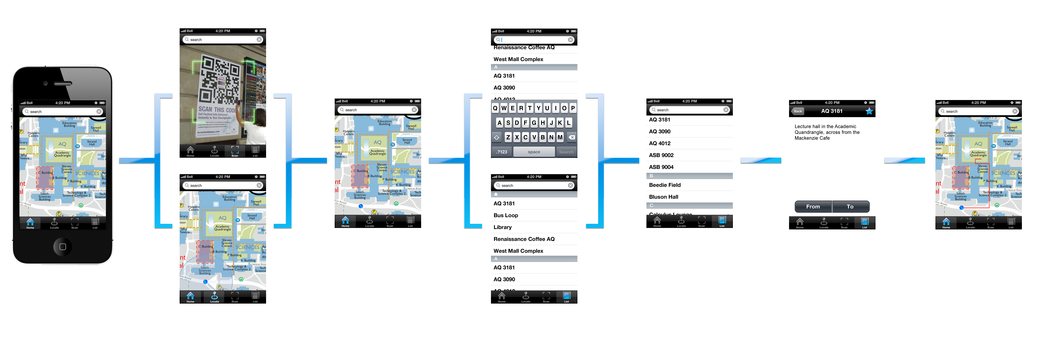
Map
Default page, this will show the general map of SFU and user can also zoom in to see the building floor plan.
List
User will need to select the location from the list of the rooms.

VI. Glossary

Detailed Map | A map with simplified building floor plan, with room numbers and pathways on the map.
General Map | A map with only building blocks and is distinguished by different colours.
GPS | Global Positioning System, a technology that is used for locating the position.
iOS | A mobile operating system developed by Apple Inc, and it is used on iPhone, iPod, and iPad.
Path Finding | A calculation that finds the shortest possible path between two location points.
Pin | The image of real-life pin, indicates a specific point on the map.
QR Code | Quick Response Code, a type of two-dimensions matrix code.

